Export the Analytics

|  |  |
| --- | --- |
| Team ID | PNT2022TMID22565 |
| Team Lead | Mahesh S M |
| Team Members | Pranav M Kabilraj S Robert Samuel J |
| Project Name | A New Hint to Transportation-Analysis of the NYC Bike Share System |

Export the Analytics

**Step 1: Sharing the Dashboard link:**

[https://us1.ca.analytics.ibm.com/bi/?perspective=dashboard&path](https://us1.ca.analytics.ibm.com/bi/?perspective=dashboard&pathRef=.my_folders%2FA%2BNew%2BHint%2Bto%2BTransportation-Analysis%2Bof%2Bthe%2BNYC%2BBike%2BShare%2BSystem&action=view&mode=dashboard&subView=model000001845bef4e71_00000000) [Ref=.my_folders%2FA%2BNew%2BHint%2Bto%2BTransportat](https://us1.ca.analytics.ibm.com/bi/?perspective=dashboard&pathRef=.my_folders%2FA%2BNew%2BHint%2Bto%2BTransportation-Analysis%2Bof%2Bthe%2BNYC%2BBike%2BShare%2BSystem&action=view&mode=dashboard&subView=model000001845bef4e71_00000000) [ion-](https://us1.ca.analytics.ibm.com/bi/?perspective=dashboard&pathRef=.my_folders%2FA%2BNew%2BHint%2Bto%2BTransportation-Analysis%2Bof%2Bthe%2BNYC%2BBike%2BShare%2BSystem&action=view&mode=dashboard&subView=model000001845bef4e71_00000000) [Analysis%2Bof%2Bthe%2BNYC%2BBike%2BShare%2BSyste](https://us1.ca.analytics.ibm.com/bi/?perspective=dashboard&pathRef=.my_folders%2FA%2BNew%2BHint%2Bto%2BTransportation-Analysis%2Bof%2Bthe%2BNYC%2BBike%2BShare%2BSystem&action=view&mode=dashboard&subView=model000001845bef4e71_00000000) [m&action=view&mode=dashboard&subView=model000001845](https://us1.ca.analytics.ibm.com/bi/?perspective=dashboard&pathRef=.my_folders%2FA%2BNew%2BHint%2Bto%2BTransportation-Analysis%2Bof%2Bthe%2BNYC%2BBike%2BShare%2BSystem&action=view&mode=dashboard&subView=model000001845bef4e71_00000000) [bef4e71_00000000](https://us1.ca.analytics.ibm.com/bi/?perspective=dashboard&pathRef=.my_folders%2FA%2BNew%2BHint%2Bto%2BTransportation-Analysis%2Bof%2Bthe%2BNYC%2BBike%2BShare%2BSystem&action=view&mode=dashboard&subView=model000001845bef4e71_00000000)

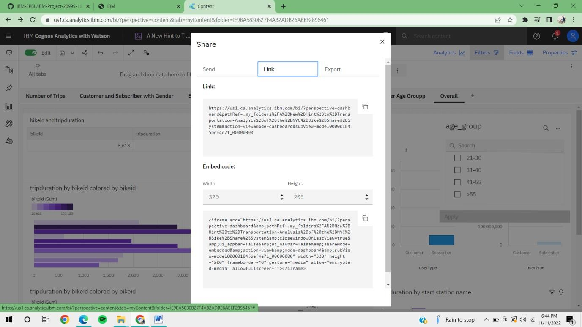

Step 2: Bulilding and Exporting the dashboard as an Document:

